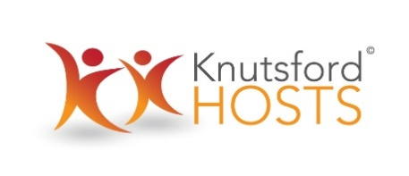

Equal Opportunities and Diversity Policy

Knutsford Hosts are committed to a policy of equal opportunity and non-discrimination that ensures equality of opportunity and diversity where those with a diverse range of experience, skills, interests, background and availability are able to participate and contribute. Knutsford Hosts will not tolerate action or behaviour that is contrary to this policy and any breach may be grounds to withdraw a Knutsford Host from volunteering opportunities.

An ‘Issues, concerns or problems’ procedure has been included (page 8) so that any volunteer can raise concerns including those about discrimination or harassment, in order that any such complaint may be addressed quickly and appropriately.

Policy Statement

At all times we aim to:

- Recruit and develop the best volunteers, basing judgement solely on suitability for the role as described
- Ensure that all Knutsford Hosts volunteers receive fair and equal treatment irrespective of gender, marital status, hours they volunteer, ethnicity, age, religion, belief, sexual orientation or disability
- Maintain a volunteering environment that welcomes diversity and is free from harassment and intimidation
- Ensure that existing and new legislative Acts based on statutory rights to equal treatment are adhered to
- Deal speedily and effectively with any complaints of alleged discrimination and/or harassment, ensuring all complaints are fully investigated and that remedial action is taken where necessary.

Recruitment of volunteers and matching volunteers to opportunities
We will recruit Knutsford Hosts volunteers in line with the approach to equality and diversity outlined above. We gather data on an Equal Opportunities monitoring form when prospective Hosts first apply, so that we can seek to ensure that Knutsford Hosts are representative of the local community.

The recruitment process includes a request for two character references, which are taken up prior to starting, and a meeting to find out what activities and events the new Knutsford Host would most like to be involved with and discuss any other considerations or needs.
Knutsford Hosts August 2019

© 2015. All rights reserved

