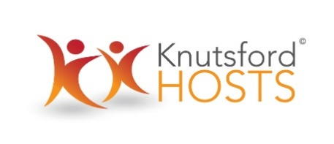

Financial Regulations Statement

These financial regulation statement governs the conduct of the financial transactions of Knutsford Hosts and may only be amended or varied by resolution of the Steering Committee.

The Steering Committee shall be responsible for the proper administration of the Knutsford Hosts’ affairs and financial management information.

Knutsford Hosts is an unincorporated community association and has no plans for income generation per se. However, from time to time it may be the recipient of sponsorship or grants and to that end has established a bank account with Barclays Bank, Knutsford.

BUDGETARY CONTROL
No expenditure of funds in the Knutsford Hosts community account may be incurred without the approval of the steering committee.

ACCOUNTING AND AUDIT
Bank statements for Knutsford Hosts will be made available to anyone with a legitimate interest.

PAYMENT OF ACCOUNTS
All payments shall be effected by cheque or other order drawn on the Knutsford Hosts’ bankers.

ORDERS FOR GOODS AND SERVICES
An official order shall be issued for all work, goods and services and copies of orders shall be retained.

Where appropriate, quotes and tenders will be sought from a range of local suppliers as Knutsford Hosts wishes to promote the local economy and where possible maximize the amount of money it spends locally, subject to best value for money being achieved.

Knutsford Hosts August 2019

© 2015. All rights reserved

